MY FAVOURITE FOOTBALLER
MY FAVOURITE FOOTBALLER IS MESSI, HE WON MANY TROPHIES, AND HE WON WORLDCUP ALSO BY PLAYING 2022 ‘FIFA WORLD CUP’, HE ALSO PLAYED IN 2026 WORLDCUP, HE PLAYED IN THE TEAM OF ARGENTINA, AND MY FAVOURITE TEAM IS ALSO ARGENTINA, MESSI HAS 8 BALLON DOR, 4 COP AMERICA TROPHIES, AND THAT’S THE REASON MOST OF PEOPLE CALLED HIM GOAT, MESSI IS MY IDOL AND I ALSO WANT TO PLAY LIKE MESSI, MARADONA IS ONE OF MY FAVOURITE FOOTBALLER, HE IS VERY OLD FOOTBALLER PLAYER AND MOST OF PEOPLE DON’T KNOW ABOUT MARADONA HE WIN 2 WORLD CUP AND MANY TROPHIES THAT’S WHY MY FAVOURITE FOOTBALLER IS MESSI OR MARADON.
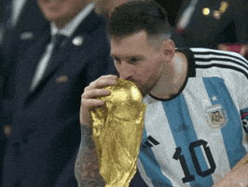

- ASIA
- PAKISTAN
- INDIA
- AFGHANISTAN
- EUROPE
- ARGENTINA
- SPAIN
- BRAZIL

STUDENTS | MATH | URDU | ENG
TAHA | 45 | 45 | 54
UMER | 35 | 34 | 56
RAZA | 67 | 67 | 76

